GROUP 1

  - Project title: Wellmeadows Hospital Database Design and Implementation

Stephen Koiseta
James Aggrey Otieno
Warren Joe Orwa

Table of Contents
Introduction 4
NORMALIZE THE FORM PROVIDED TO THE THIRD NORMAL FORM 4
UNF (Unnormalized Form) 4
1NF: flatten using a composite key so every row is atomic 4
2NF: remove partial dependencies, split off attributes that depend on only part of the key 4
3NF (final): remove transitive dependencies, split Ward out of Patient 5
2. Design the ERD 5
Entity list and relationships 5
Relationships 6
Implement the resulting relational database in MySQL. 7
1. Function: CheckMedicationStock() 7
2. Transaction: Recording a New Prescription 8
3. Stored Procedure: PrescribeMedication() 9
4. Trigger: Preventing Negative Stock 10
4. Write SQL queries to answer any FOUR of the following management questions: 11
1 List all admitted patients and their assigned ward 11
2 Identify medications below reorder level 11
3 Calculate medication usage by ward 11
4 Identify patients receiving multiple medications 12
Oracle Implementation 12
1. Ward, Patient, Staff, Admission data 12
2. Accessor and CalculateCost 13
3. Mutator proof for Medication 13
4. Accessor for Prescription 14
5. Prescription 14
6. The object model overview showing all types and REF relationships resolved together in one readable table 14
MongoDB Atlas Implementation 16
Creating Queries 16
2. Find patients receiving a specific medication. 16
3. Find medications below reorder level. 17
4. Find prescriptions issued within a date range. 17
5. Find patients occupying a specific bed. 18
Creating Aggregation Pipelines 18
1. Calculate medication usage by ward. 18
2. Determine the most prescribed drugs. 20
3. Calculate inventory valuation. 20
4. Determine average prescriptions per patient. 21
Comparative Analysis 23
Relational Database (MySQL) 23
Object-Oriented Database (Oracle) 23
NoSQL Database (MongoDB) 24
Conclusion 24

Introduction
This report presents the design and implementation of the Wellmeadows Hospital database system. We built the same hospital data in three different database types, and this method lets us directly compare the design, the data structure, and the queries in each one.
First, we built the relational model in MySQL. We normalized the source data to Third Normal Form, and then we created an Entity-Relationship Diagram from the normalized data. As a result, our final schema has tables for wards, beds, patients, staff, medication, admissions, and prescriptions. We also added a function, a transaction, a stored procedure, and a trigger, so these parts work together to protect the data and manage the medication stock correctly.
Next, we built the object-oriented model in Oracle Database. We represented each entity as an object type, and we gave each object type its own methods. These methods read data, change data, calculate medication cost, and display prescription details.
After that, we built the NoSQL document model in MongoDB Atlas. We stored each entity as a JSON document in a collection, and we wrote find queries and aggregation pipelines to retrieve and summarize the hospital data. Finally, in the last section of this report, we compared the three database types, focusing on data access and performance.

NORMALIZE THE FORM PROVIDED TO THE THIRD NORMAL FORM

UNF (Unnormalized Form)
PatientMedForm (
PatientNumber, FullName, WardNumber, WardName, BedNumber,
DrugNumber, DrugName, Description, Dosage, MethodOfAdmin,
UnitsPerDay, StartDate, FinishDate
)
Problem: repeating group; a patient can have many drug rows.

1NF: flatten using a composite key so every row is atomic
PatientMedForm (
PatientNumber, FullName, WardNumber, WardName, BedNumber,
DrugNumber, DrugName, Description, Dosage, MethodOfAdmin,
UnitsPerDay, StartDate, FinishDate
)
Primary Key is (PatientNumber, DrugNumber, StartDate)
Problem: partial dependencies; several attributes depend on only part of the composite key.

2NF: remove partial dependencies, split off attributes that depend on only part of the key
Patient (PatientNumber, FullName, WardNumber, WardName, BedNumber)
PK = PatientNumber

Drug (DrugNumber, DrugName, Description)
Primary Key is DrugNumber

Prescription (PatientNumber, DrugNumber, StartDate, Dosage, MethodOfAdmin, UnitsPerDay, FinishDate)
Primary Key is (PatientNumber, DrugNumber, StartDate)
FK PatientNumber: Patient
FK DrugNumber: Drug
Problem: transitive dependency; WardName depends on WardNumber, not directly on PatientNumber.

3NF (final): remove transitive dependencies, split Ward out of Patient
Patient (PatientNumber, FullName, WardNumber, BedNumber)
PK = PatientNumber
FK WardNumber; Ward

Ward (WardNumber, WardName)
PK = WardNumber

Drug (DrugNumber, DrugName, Description)
PK = DrugNumber

Prescription (PatientNumber, DrugNumber, StartDate, Dosage, MethodOfAdmin, UnitsPerDay, FinishDate)
PK = (PatientNumber, DrugNumber, StartDate)
FK PatientNumber; Patient
FK DrugNumber; Drug
No partial dependencies, no transitive dependencies; every non-key attribute depends on the whole key, and nothing but the key.

2. Design the ERD

Entity list and relationships
Entity | Key attributes
Ward | WardNumber (PK), WardName
Bed | WardNumber (PK, FK), BedNumber (PK)
Patient | PatientNumber (PK), FullName
Admission | AdmissionID (PK), PatientNumber (FK), WardNumber+BedNumber (FK), AdmissionDate, DischargeDate
Staff | StaffID (PK), StaffName, Role
Medication | DrugNumber (PK), DrugName, Description, QuantityInStock, ReorderLevel
Prescription | AdmissionID (FK), DrugNumber (FK), StartDate, Dosage, MethodOfAdmin, UnitsPerDay, FinishDate - PK = (AdmissionID, DrugNumber, StartDate)

Relationships
- Ward 1-to-many Bed
- Ward 1 -to-many Admission (a ward hosts many admissions)
- Bed 1 -to-many Admission (a bed hosts many admissions over time)
- Patient 1 -to-many Admission
- Staff 1 -to-many Prescription
- Admission 1 -to-many Prescription
- Medication 1 -to-many Prescription
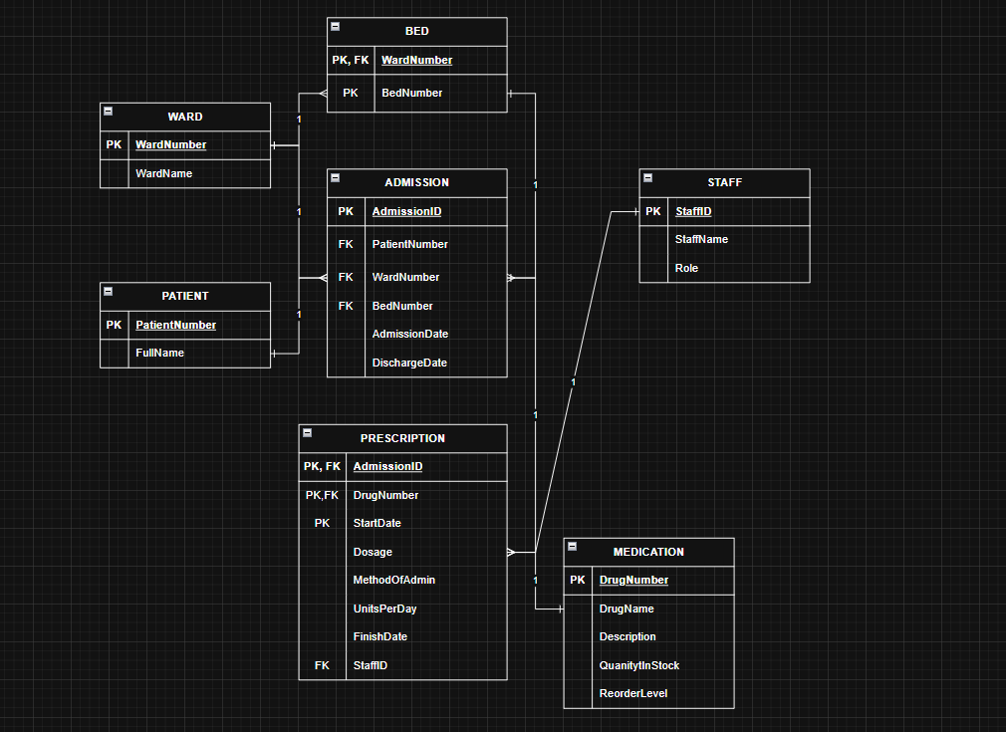

Implement the resulting relational database in MySQL.
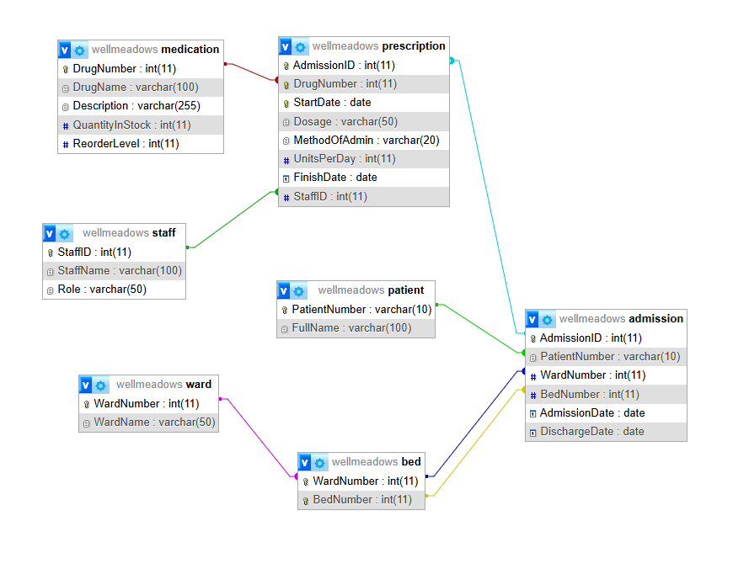

1. Function: CheckMedicationStock()
Create a function CheckMedicationStock() that accepts a Medication ID and returns the quantity in stock.
DELIMITER //
CREATE FUNCTION CheckMedicationStock(
p_DrugNumber INT
)
RETURNS INT
DETERMINISTIC
READS SQL DATA
BEGIN
DECLARE v_CurrentStock INT;

SELECT QuantityInStock INTO v_CurrentStock
FROM Medication
WHERE DrugNumber = p_DrugNumber;
RETURN v_CurrentStock;
END //
DELIMITER ;
This function takes a single Medication ID (DrugNumber) as input, looks up the corresponding row in the Medication table, and returns the current QuantityInStock as an integer. It performs a read-only lookup and does not modify any data, which is why it is marked DETERMINISTIC and READS SQL DATA. The stock-sufficiency comparison itself is deliberately left to the calling procedure, keeping the function focused on a single responsibility: reporting the current stock level for a given drug.

2. Transaction: Recording a New Prescription
Create a transaction that records a new prescription. It should verify the medication is available using the function above, record the prescription, and reduce the stock. If the quantity in stock is insufficient, it should roll back.
The transaction logic is embedded inside the stored procedure described in Section 3 below (this is standard practice in MySQL, since transactions are typically wrapped inside a routine so they can be invoked repeatedly with different parameters). The relevant transaction control statements are:
START TRANSACTION;
IF v_CurrentStock >= v_QuantityNeeded THEN
INSERT INTO Prescription (...) VALUES (...);
UPDATE Medication
SET QuantityInStock = QuantityInStock - v_QuantityNeeded
WHERE DrugNumber = p_DrugNumber;
COMMIT;
ELSE
ROLLBACK;
SIGNAL SQLSTATE '45000'
SET MESSAGE_TEXT = 'Insufficient medication stock to fulfil this prescription.';
END IF;
The transaction first calls CheckMedicationStock() to retrieve the current stock level, then compares it against the total quantity needed for the prescribed course of treatment. If sufficient stock exists, both the INSERT (new prescription record) and the UPDATE (reduced stock level) are committed together as a single atomic unit. If stock is insufficient, the transaction is rolled back so that neither the prescription nor the stock is changed, and a custom error is raised using SIGNAL to inform the caller of the failure.

3. Stored Procedure: PrescribeMedication()
Requirement: Create a stored procedure that allows a user to prescribe medication using the transaction above.
DELIMITER //
CREATE PROCEDURE PrescribeMedication(
IN p_AdmissionID INT,
IN p_DrugNumber INT,
IN p_StartDate DATE,
IN p_Dosage VARCHAR(50),
IN p_MethodOfAdmin VARCHAR(20),
IN p_UnitsPerDay INT,
IN p_FinishDate DATE,
IN p_StaffID INT
)
BEGIN
DECLARE v_QuantityNeeded INT;
DECLARE v_CurrentStock INT;
SET v_QuantityNeeded = p_UnitsPerDay * DATEDIFF(p_FinishDate, p_StartDate);
SET v_CurrentStock = CheckMedicationStock(p_DrugNumber);
START TRANSACTION;
IF v_CurrentStock >= v_QuantityNeeded THEN
INSERT INTO Prescription
(AdmissionID, DrugNumber, StartDate, Dosage, MethodOfAdmin, UnitsPerDay, FinishDate, StaffID)
VALUES
(p_AdmissionID, p_DrugNumber, p_StartDate, p_Dosage, p_MethodOfAdmin, p_UnitsPerDay, p_FinishDate, p_StaffID);
UPDATE Medication
SET QuantityInStock = QuantityInStock - v_QuantityNeeded
WHERE DrugNumber = p_DrugNumber;
COMMIT;
ELSE
ROLLBACK;
SIGNAL SQLSTATE '45000'
SET MESSAGE_TEXT = 'Insufficient medication stock to fulfil this prescription.';
END IF;
END //
DELIMITER ;
This procedure gives hospital staff a single, simple entry point for prescribing medication: CALL PrescribeMedication(...). Internally it calculates the total quantity needed by multiplying UnitsPerDay by the number of days between StartDate and FinishDate (using DATEDIFF), retrieves the current stock via CheckMedicationStock(), and then executes the transaction from Section 2. Wrapping the transaction in a procedure means the same validated logic runs identically every time it is called, rather than staff writing raw INSERT/UPDATE statements by hand.

4. Trigger: Preventing Negative Stock
Requirement: Create a BEFORE UPDATE trigger that validates pharmaceutical inventory quantities by preventing negative stock values or unrealistic stock quantities.
DELIMITER //
CREATE TRIGGER trg_PreventNegativeStock
BEFORE UPDATE ON Medication
FOR EACH ROW
BEGIN
IF NEW.QuantityInStock < 0 THEN
SIGNAL SQLSTATE '45000'
SET MESSAGE_TEXT = 'Stock quantity cannot be reduced below zero.';
END IF;
END //
DELIMITER ;
This trigger fires automatically before any UPDATE statement is applied to the Medication table, regardless of whether the update comes from the PrescribeMedication procedure or from a direct manual UPDATE. It checks the proposed new value (NEW.QuantityInStock); if it would be negative, the trigger raises a custom error and blocks the update entirely. This acts as an independent safety net at the database level, ensuring data integrity is protected even if application code bypasses the stored procedure.

4. Write SQL queries to answer any FOUR of the following management questions:

1 List all admitted patients and their assigned ward
SELECT p.PatientNumber, p.FullName, w.WardNumber, w.WardName, a.BedNumber, a.AdmissionDate
FROM Patient p
JOIN Admission a ON p.PatientNumber = a.PatientNumber
JOIN Ward w ON a.WardNumber = w.WardNumber
WHERE a.DischargeDate IS NULL;
This query joins Patient, Admission, and Ward to show each currently admitted patient alongside their ward and bed. A patient is treated as currently admitted when their Admission record has no DischargeDate, since a NULL discharge date indicates the stay is still ongoing.

2 Identify medications below reorder level
SELECT DrugNumber, DrugName, QuantityInStock, ReorderLevel
FROM Medication
WHERE QuantityInStock < ReorderLevel;
This is a simple filter on the Medication table, comparing each drug's current stock level against its own reorder level. No joins are needed since both values live in the same table. This query helps hospital pharmacy staff quickly identify which medications need to be reordered.

3 Calculate medication usage by ward
SELECT w.WardNumber, w.WardName, m.DrugName, SUM(pr.UnitsPerDay) AS TotalUnitsPrescribedPerDay
FROM Prescription pr
JOIN Admission a ON pr.AdmissionID = a.AdmissionID
JOIN Ward w ON a.WardNumber = w.WardNumber
JOIN Medication m ON pr.DrugNumber = m.DrugNumber
GROUP BY w.WardNumber, w.WardName, m.DrugName
ORDER BY w.WardNumber;
This query joins across Prescription, Admission, Ward, and Medication to connect each prescription back to the ward in which it was issued. It then groups the results by ward and drug, summing UnitsPerDay to show total daily medication usage per ward. This kind of aggregation supports hospital resource planning at the ward level.

4 Identify patients receiving multiple medications
SELECT p.PatientNumber, p.FullName, COUNT(DISTINCT pr.DrugNumber) AS NumberOfMedications
FROM Patient p
JOIN Admission a ON p.PatientNumber = a.PatientNumber
JOIN Prescription pr ON a.AdmissionID = pr.AdmissionID
GROUP BY p.PatientNumber, p.FullName
HAVING COUNT(DISTINCT pr.DrugNumber) > 1;
This query groups prescriptions by patient and counts the number of distinct medications each patient has received across all their admissions. The HAVING clause then filters the grouped results to keep only patients with more than one distinct medication. This differs from a simple WHERE filter because the condition (count > 1) depends on an aggregate value that only exists after grouping.

Oracle Implementation

1. Ward, Patient, Staff, Admission data
These four query results show the data in the Ward, Patient, Staff, and Admission object tables. Each row is an object and not a normal table row. The queries prove that the data exists in each object table. The Admission query also proves that the REF links to Patient and Ward work.
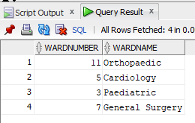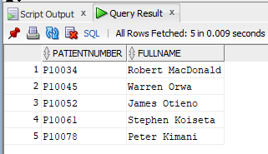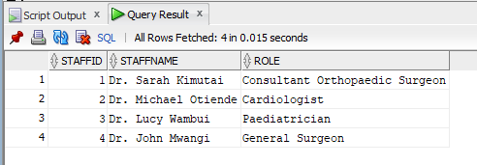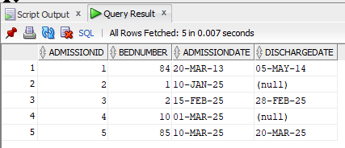
Codes to show the above data:
1. SELECT * FROM Ward_OT;
2. SELECT * FROM Patient_OT;
3. SELECT * FROM Staff_OT;
4. SELECT AdmissionID, BedNumber, AdmissionDate, DischargeDate FROM Admission_OT;

2. Accessor and CalculateCost
This query results shows a call on two methods on the Medication object. GetDrugName() is the Accessor method. It returns the drug name. CalculateCost(50) multiplies 50 units by the unit cost. It returns the total cost. The output proves that both methods work.
Code:
SELECT m.DrugNumber, m.GetDrugName() AS DrugName, m.CalculateCost(50) AS CostFor50Units
FROM Medication_OT m
WHERE m.DrugNumber = 10223;
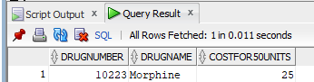

3. Mutator proof for Medication
This query result shows the stock level for Insulin. The stock level was 300 units before. The SetQuantityInStock() method changed the stock level to 250 units. The output proves that the Mutator method changed the data.
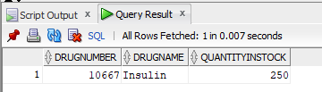
Code:
SELECT DrugNumber, DrugName, QuantityInStock FROM Medication_OT WHERE DrugNumber = 10667;

4. Accessor for Prescription
This query results shows a call to the GetDosage() Accessor method. The SetDosage() method changed the dosage from “5 units” to “10 units” before the query ran. The output proves that the Accessor method reads the new value.
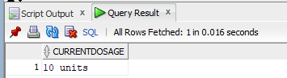
Code:
SELECT p.GetDosage() AS CurrentDosage
FROM Prescription_OT p
WHERE p.StartDate = DATE '2025-03-02';

5. Prescription
This query result shows a call to the DisplayPrescription() method on each prescription. The method builds one line of text for each prescription. It uses DEREF to get the drug name from the Medication object. The output proves that the method works for all seven prescriptions.
Codes:
SELECT p.DisplayPrescription() FROM Prescription_OT p;
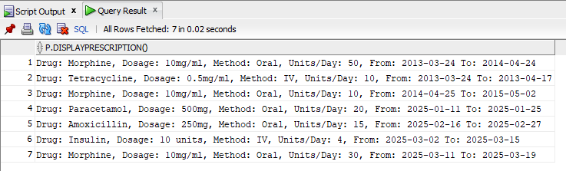

6. The object model overview showing all types and REF relationships resolved together in one readable table
This query result shows the use of DEREF on two REF attributes. The first DEREF gets the patient name through the PatientRef pointer. The second DEREF gets the ward name through the WardRef pointer. The output shows that both REF links work.
Code
SELECT
a.AdmissionID,
DEREF(a.PatientRef).FullName AS PatientName,
DEREF(a.WardRef).WardName AS Ward,
a.BedNumber
FROM Admission_OT a;
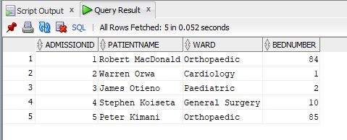

MongoDB Atlas Implementation
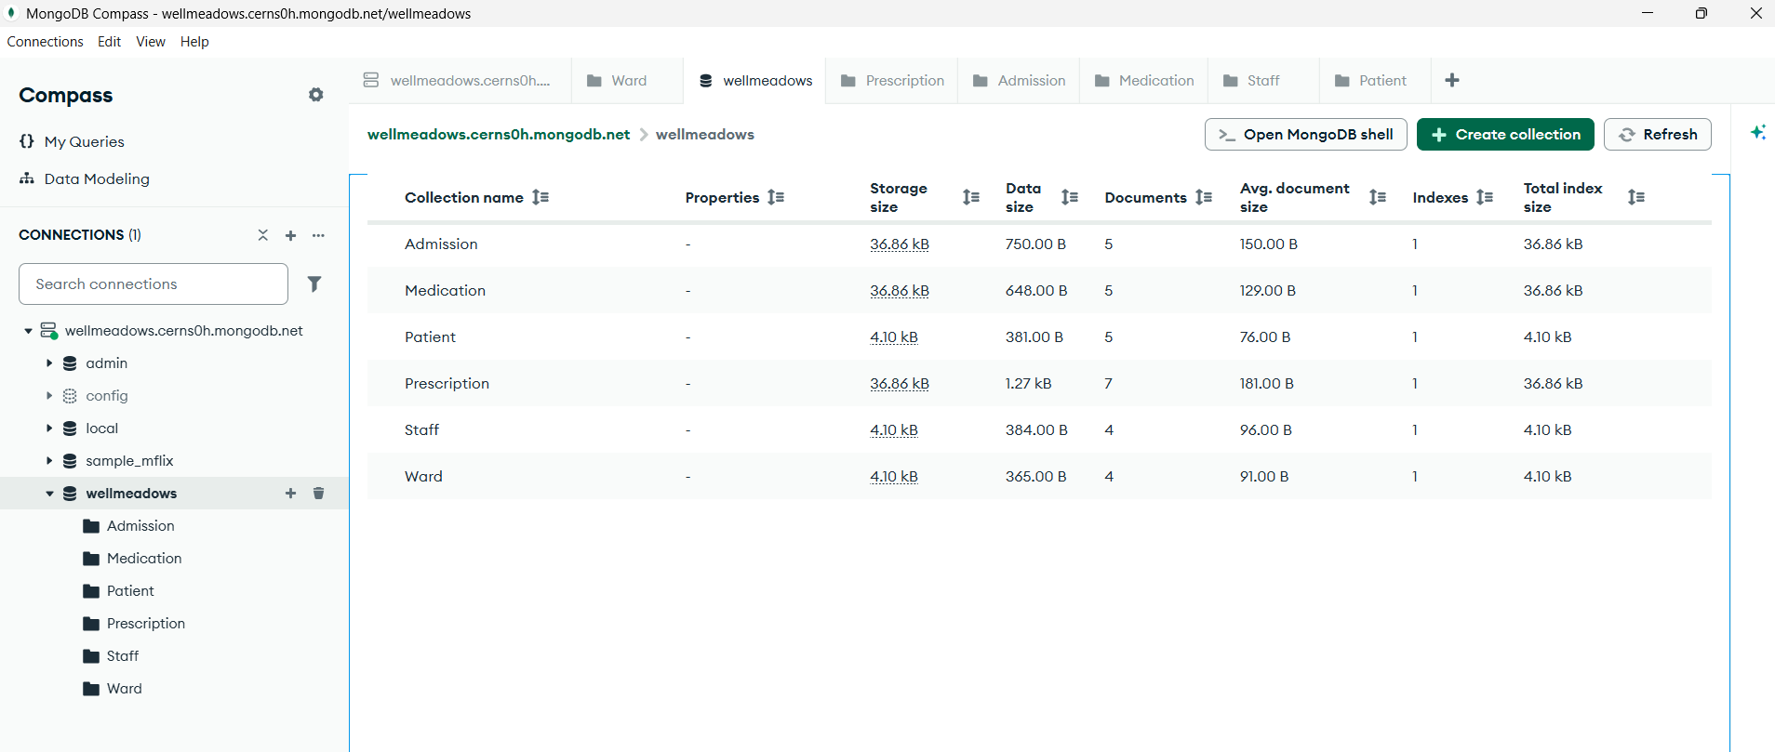

Creating Queries
1. Find patients in a specified ward.
For our implementation, Ward isn't stored on Patient directly, but it lives on Admission, so we query Admission.
This query searches the Admission collection. It finds all documents with the ward number 11. The result shows the patients in Ward 11.
Query: { "WardNumber": 11 }
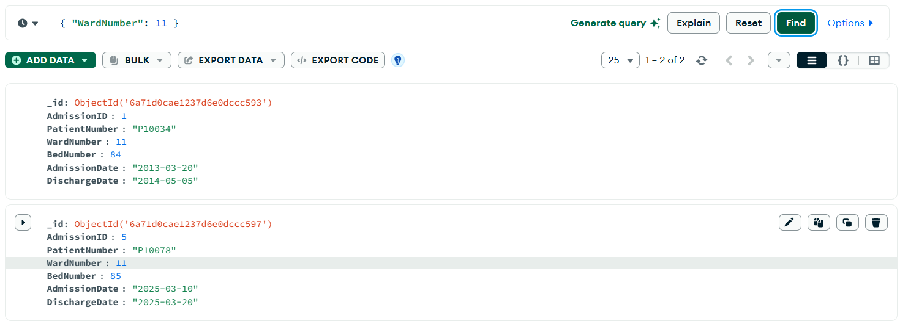

2. Find patients receiving a specific medication.
Under Prescriptions.
This query searches the Prescription collection. It finds all documents with the drug number for Morphine. The result shows which admissions received this drug.
The Query: { "DrugNumber": 10223 }
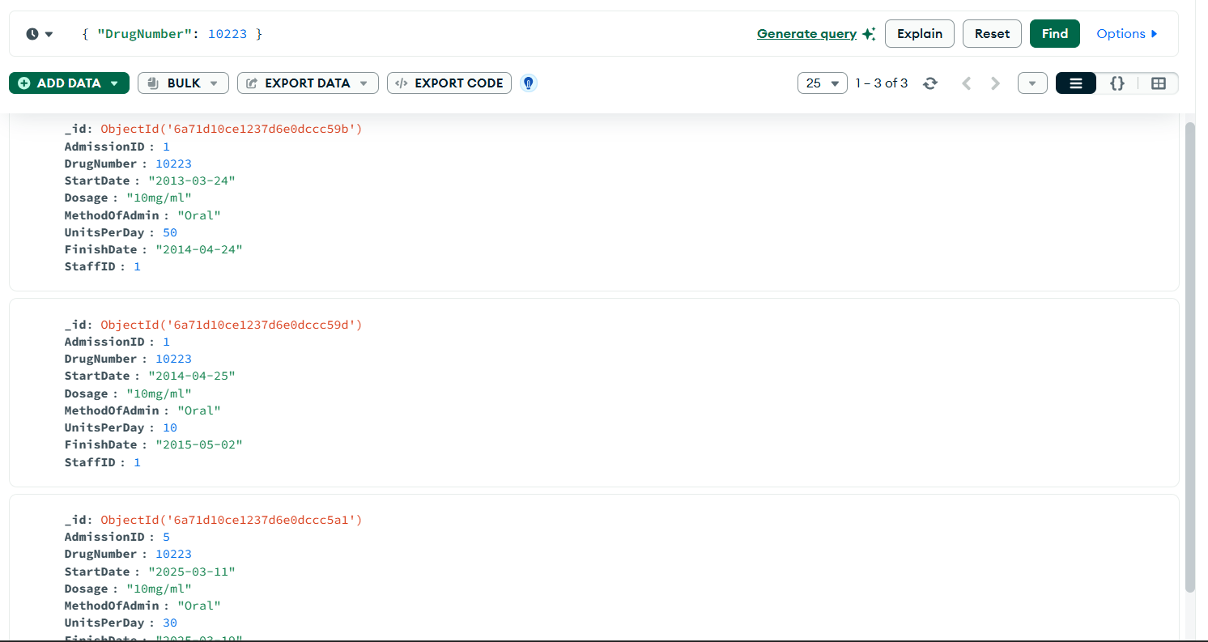

3. Find medications below reorder level.
This query searches the Medication collection. It uses $expr to compare two fields in the same document. The query finds drugs where the stock quantity is less than the reorder level. The result shows drugs that need a new order.
Query: { "$expr": { "$lt": ["$QuantityInStock", "$ReorderLevel"] } }
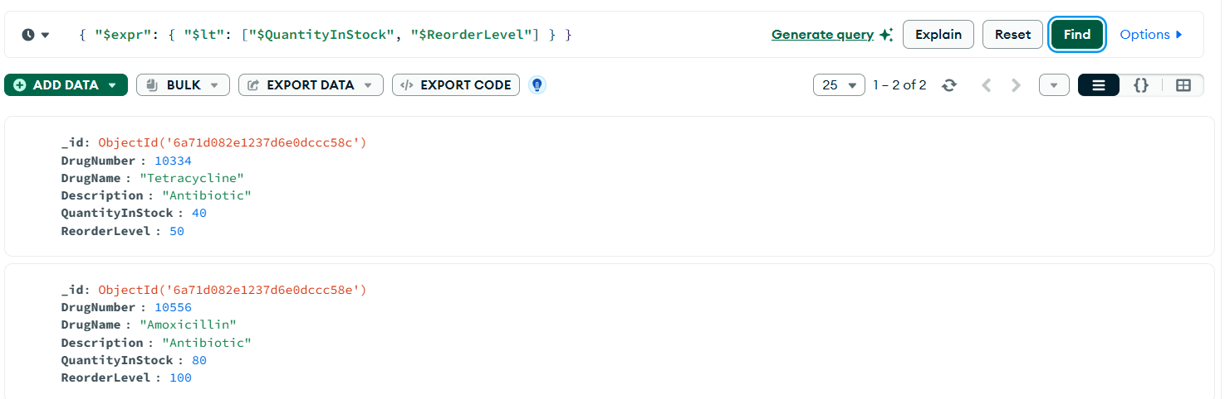

4. Find prescriptions issued within a date range.
This query searches the Prescription collection. It finds documents with a start date between two given dates. The result shows all prescriptions from that time period.
Query: { "StartDate": { "$gte": "2025-01-01", "$lte": "2025-12-31" } }
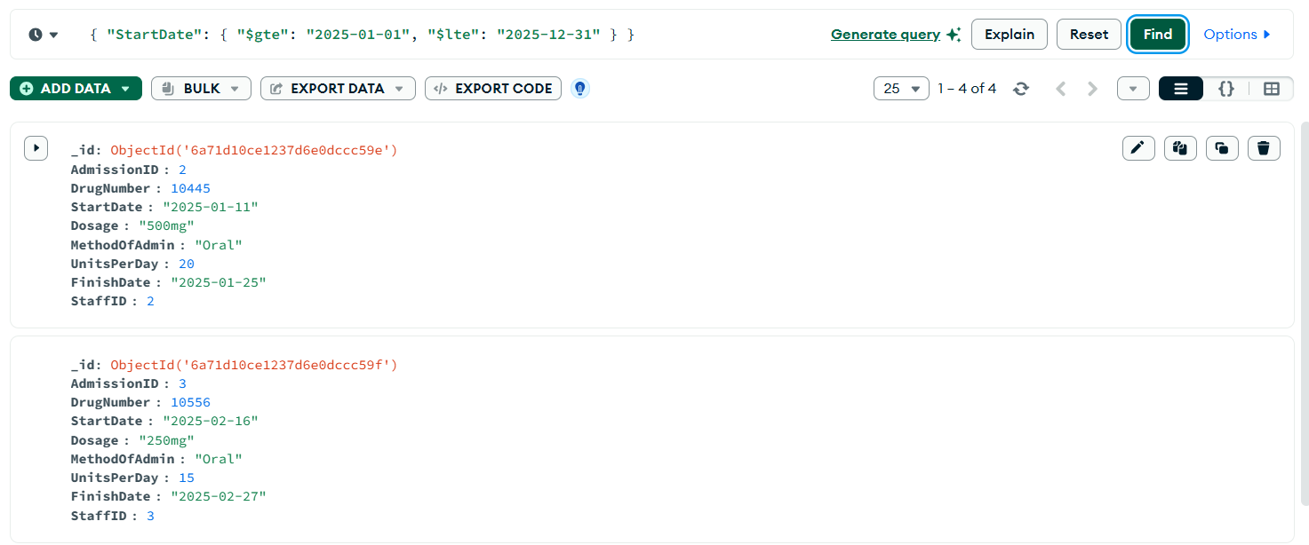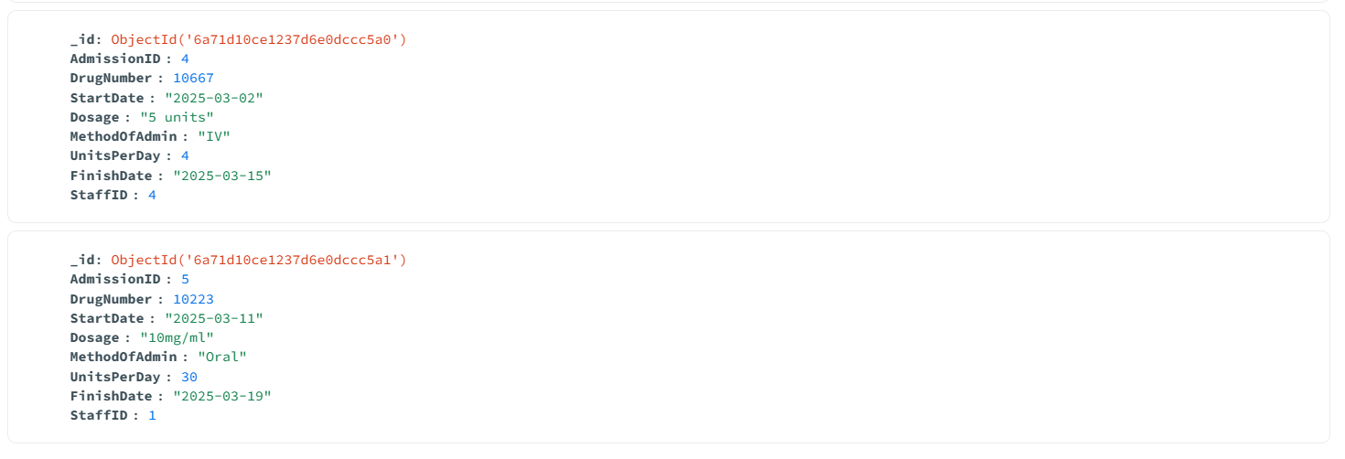

5. Find patients occupying a specific bed.
This query searches the Admission collection. It finds a document that matches a ward number, a bed number, and a null discharge date. A null discharge date means the patient has not left yet. The result shows the patient who is in the bed now.
{ "WardNumber": 5, "BedNumber": 1, "DischargeDate": null }
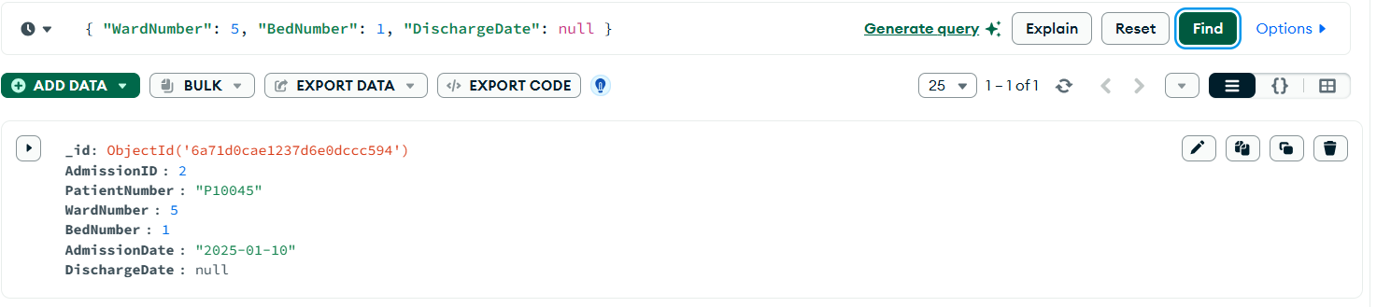

Creating Aggregation Pipelines

1. Calculate medication usage by ward.
This pipeline has three stages.
- Stage 1 ($lookup): This stage joins the Prescription collection with the Admission collection. It adds the ward number to each prescription. This step is necessary because the ward number is not stored in the Prescription collection.
- Stage 2 ($unwind): This stage takes the joined data out of an array. It puts the data into a normal document. This step makes the data ready for the next stage.
- Stage 3 ($group): This stage groups all prescriptions by ward number. It adds the units per day for each ward. The result shows the total medication use for each ward.
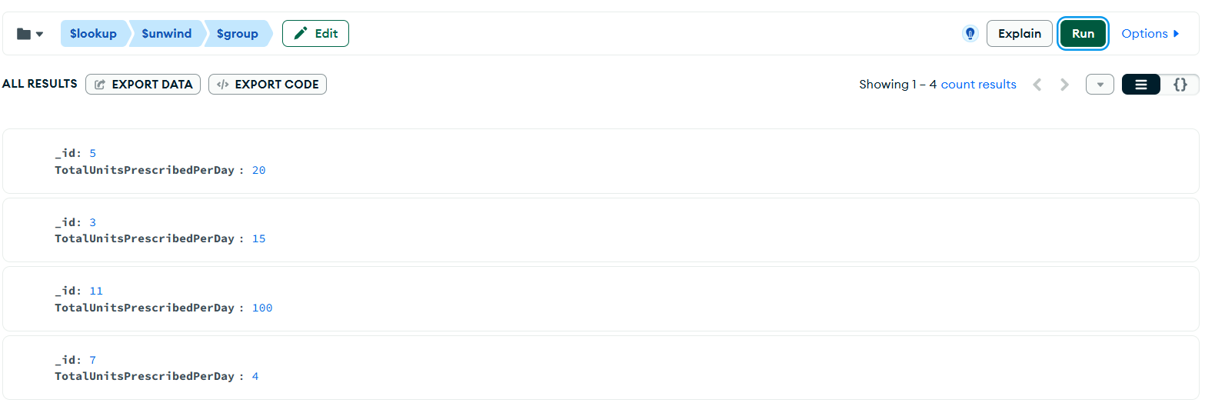
Codes
db.Prescription.aggregate([
{
$lookup: {
from: "Admission",
localField: "AdmissionID",
foreignField: "AdmissionID",
as: "admissionInfo"
}
},
{ $unwind: "$admissionInfo" },
{
$group: {
_id: "$admissionInfo.WardNumber",
TotalUnitsPrescribedPerDay: { $sum: "$UnitsPerDay" }
}
}
])

2. Determine the most prescribed drugs.
This pipeline has three stages.
- Stage 1 ($group): This stage groups all prescriptions by drug number. It counts how many times each drug appears. The result shows a count for each drug.
- Stage 2 ($sort): This stage puts the drugs in order. The drug with the highest count comes first.
- Stage 3 ($limit): This stage keeps only the top drugs. The result shows the most prescribed drugs.
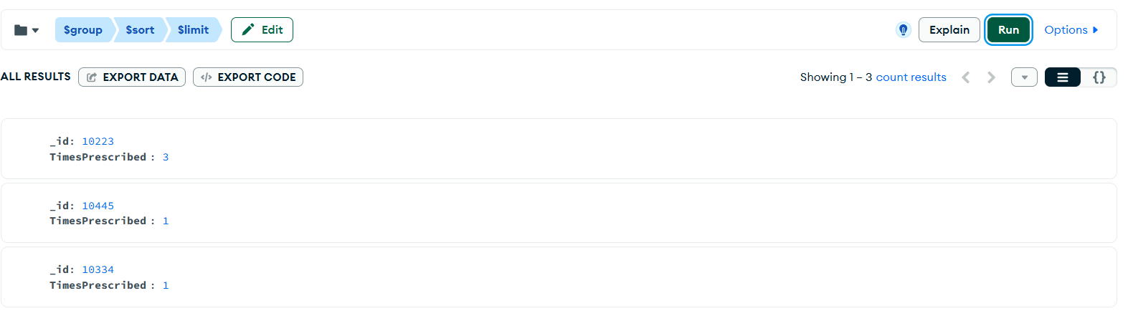
Codes
db.Prescription.aggregate([
{
$group: {
_id: "$DrugNumber",
TimesPrescribed: { $sum: 1 }
}
},
{ $sort: { TimesPrescribed: -1 } },
{ $limit: 3 }
])

3. Calculate inventory valuation.
This pipeline has two stages.
- Stage 1 ($project): This stage calculates the value of each drug. It multiplies the stock quantity by the unit cost. The result shows a stock value for each drug.
- Stage 2 ($group): This stage adds the stock value of all drugs together. It uses _id: null because the total is for the whole inventory, not for one group. The result shows the total value of all medication in stock.
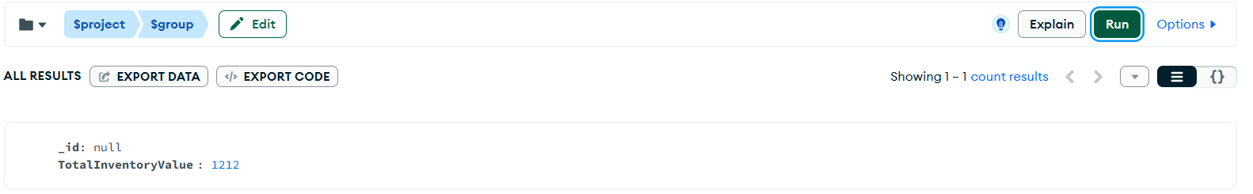
Code
db.Medication.aggregate([
{
$project: {
DrugName: 1,
QuantityInStock: 1,
UnitCost: 1,
StockValue: { $multiply: ["$QuantityInStock", "$UnitCost"] }
}
},
{
$group: {
_id: null,
TotalInventoryValue: { $sum: "$StockValue" }
}
}
])

4. Determine average prescriptions per patient.
This pipeline has four stages.
- Stage 1 ($lookup): This stage joins the Prescription collection with the Admission collection. It adds the patient number to each prescription. This step is necessary because the patient number is not stored in the Prescription collection.
- Stage 2 ($unwind): This stage takes the joined data out of an array. It prepares the data for grouping.
- Stage 3 ($group): This stage counts the prescriptions for each patient. The result shows a prescription count for each patient.
- Stage 4 ($group): This stage calculates the average of all the counts from Stage 3. It uses _id: null because the average is for all patients together. The result shows the average number of prescriptions per patient.
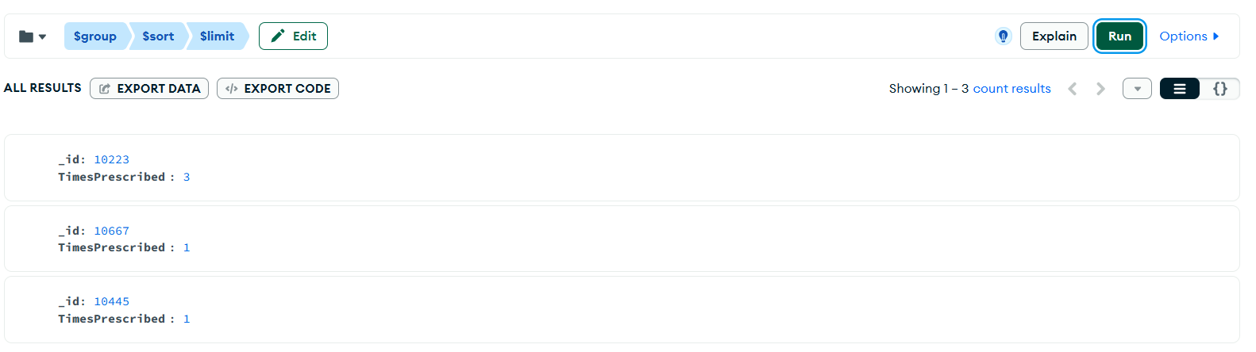
Code
db.Prescription.aggregate([
{
$lookup: {
from: "Admission",
localField: "AdmissionID",
foreignField: "AdmissionID",
as: "admissionInfo"
}
},
{ $unwind: "$admissionInfo" },
{
$group: {
_id: "$admissionInfo.PatientNumber",
PrescriptionCount: { $sum: 1 }
}
},
{
$group: {
_id: null,
AveragePrescriptionsPerPatient: { $avg: "$PrescriptionCount" }
}
}
])

Comparative Analysis
We implemented the Wellmeadows Hospital system three times, and this repetition gives us direct evidence for comparing the three database types. We compare each type on two points: data access and performance.

Relational Database (MySQL)
The relational model organizes data into separate tables, and each table connects to the others through foreign keys. This structure gives us a clear advantage in data integrity, because MySQL enforces every relationship automatically. For example, our ‘BEFORE UPDATE’ trigger blocks negative stock values without any extra code in the application layer.
However, this structure also creates a disadvantage in data access for complex questions. Our “medication usage by ward” query needed four separate tables; Prescription, Admission, Ward, and Medication, joined together with ‘JOIN’ clauses. Each join adds processing work for the database engine, so performance can slow down as the data grows larger or the joins increase in number. Our sample data is small, so we did not see this slowdown ourselves, but it is a known limitation of the relational model at a larger scale.

Object-Oriented Database (Oracle)
The object-oriented model organizes data into object types, and each object type can carry its own methods. This gives us an advantage that the relational model does not have: behavior lives with the data itself. For example, our ‘CalculateCost()’ method sits directly inside ‘MedicationType’, so any part of the database can call it without duplicating the calculation logic elsewhere.
On the other hand, this model creates a disadvantage in data access, because navigating between objects requires ‘REF’ and ‘DEREF’ operations instead of simple joins. Our ‘DisplayPrescription()’ method needed a ‘DEREF’ call just to reach the medication name through a pointer. This approach works well for our project's size, but the syntax is more complex than a standard SQL join, and it took longer for us to write and debug correctly. We also found that Oracle object tables do not support composite primary keys in the same direct way that relational tables do, so we could not fully replicate the composite key we used for Prescription in MySQL.

NoSQL Database (MongoDB)
The document model organizes data into flexible JSON documents, and each document can hold different fields without a fixed schema. This gives us a clear advantage in data access speed for our aggregation pipelines. For example, our “average prescriptions per patient” pipeline needed only one ‘$lookup’ stage to join Prescription with Admission, compared to a full ‘JOIN’ clause pattern in SQL. Aggregation pipelines are also built for exactly this kind of summary calculation, so MongoDB handled the grouping and averaging steps efficiently.
However, this model creates a disadvantage in data integrity, because MongoDB does not enforce foreign key constraints. In our design, the ‘PatientNumber’ field inside an Admission document is only a plain value, and MongoDB does not check that this value exists in the Patient collection. This means an error in application code could create a broken reference, and the database itself would not catch it. The relational and object-oriented models both prevent this kind of error automatically, through foreign keys and ‘SCOPE FOR’ clauses.

Conclusion
Each database type shows a different balance between data integrity and data access flexibility. The relational model gives us the strongest automatic protection for our data, but complex questions need more joins. The object-oriented model lets us attach behavior directly to our data, but navigating relationships needs more complex syntax. The NoSQL model gives us the fastest and simplest queries for summary calculations, but it places the responsibility for data integrity on us, not on the database.

